First of all create repo

Copy link of repo as below

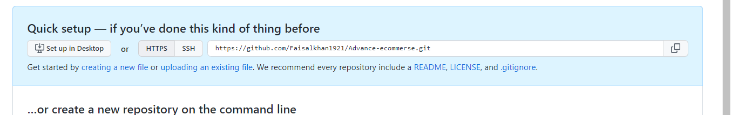

<https://github.com/Faisalkhan1921/Advance-ecommerse.git>

open gitbash in project folder directory

git init

git add .

git commit –m “multi auth with theme”

git branch -M main

git remote add origin <https://github.com/Faisalkhan1921/Advance-ecommerse.git>

git push –u origin master

hms

<https://github.com/Faisalkhan1921/hospital_management_system-Laravel.git>